A dance club is conducting auditions to admit interested candidates. You need to implement a Participant class for the dance club based on the class diagram and description given below.

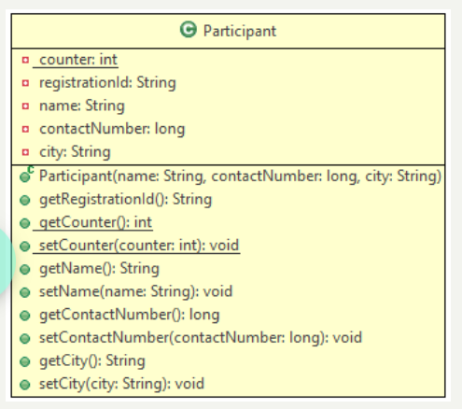

**Method Description**

**Partcipant(String name, long contactNumber, String city)**

* Initialize the name, contactNumber and city instance variables appropriately with the values passed to the constructor.
* Generate the registrationId using the static variable counter. The value of registrationId should start from 'D10001' and the numerical part should be incremented by 1 for the subsequent values. Initialize the counter in static block.

Implement the appropriate getter and setter methods.

Test the functionalities using the provided Tester class. Create two or more Participant objects and validate that the values of the member variables are proper.

**Sample Input and Output**

**For constructor**

**Input**

For first Participant object

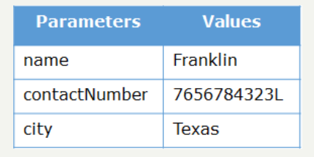

For second Participant object

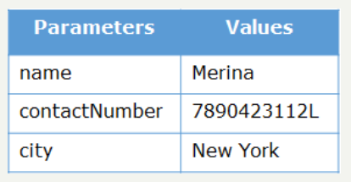

**Output**

